1.Fibonacci using Recursion:

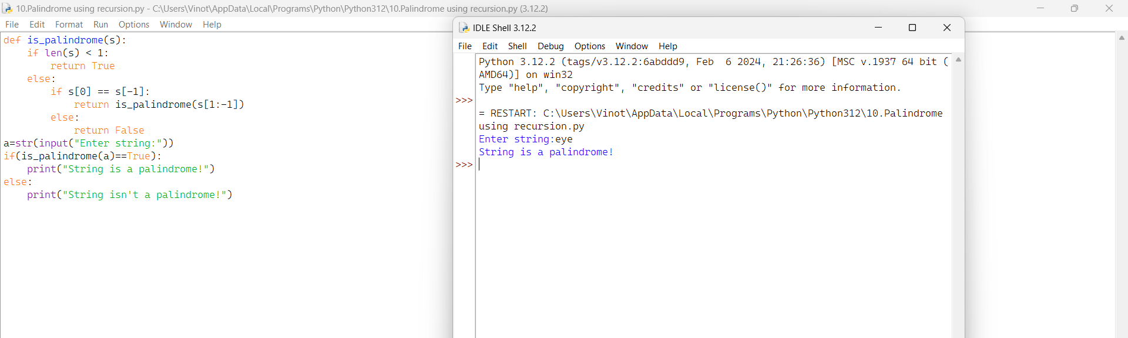

2.Check whether the given number is armstrong or not

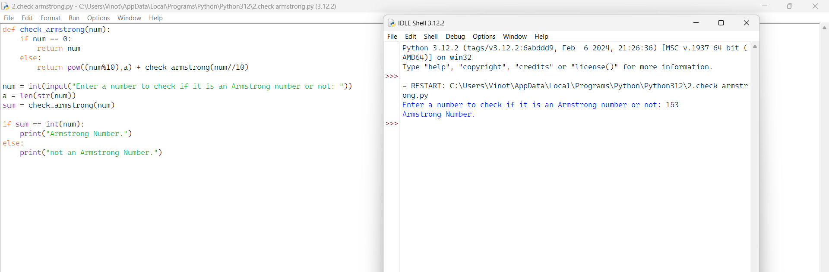

3.Calculate GCD of two numbers

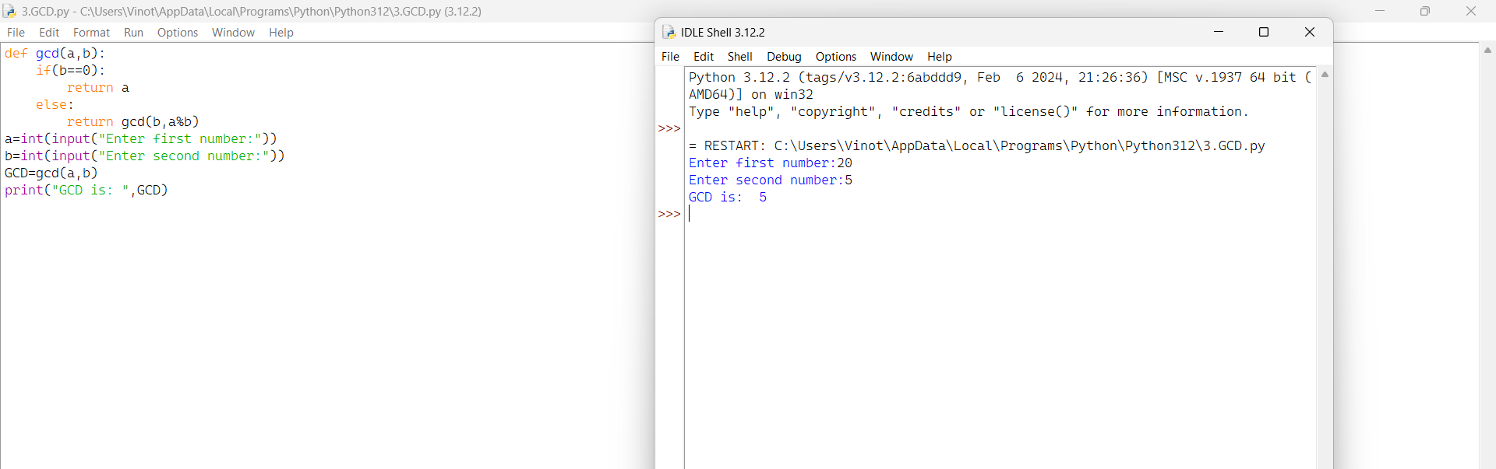

4.Largest element in an array

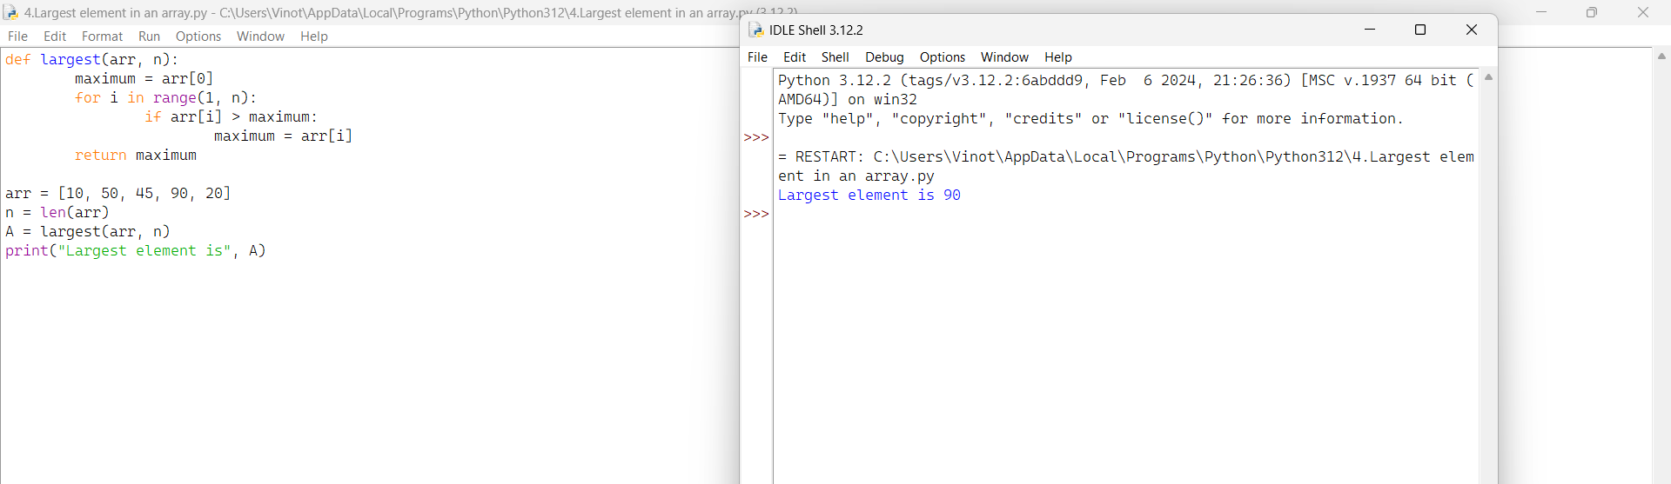

5.Factorial using recursion

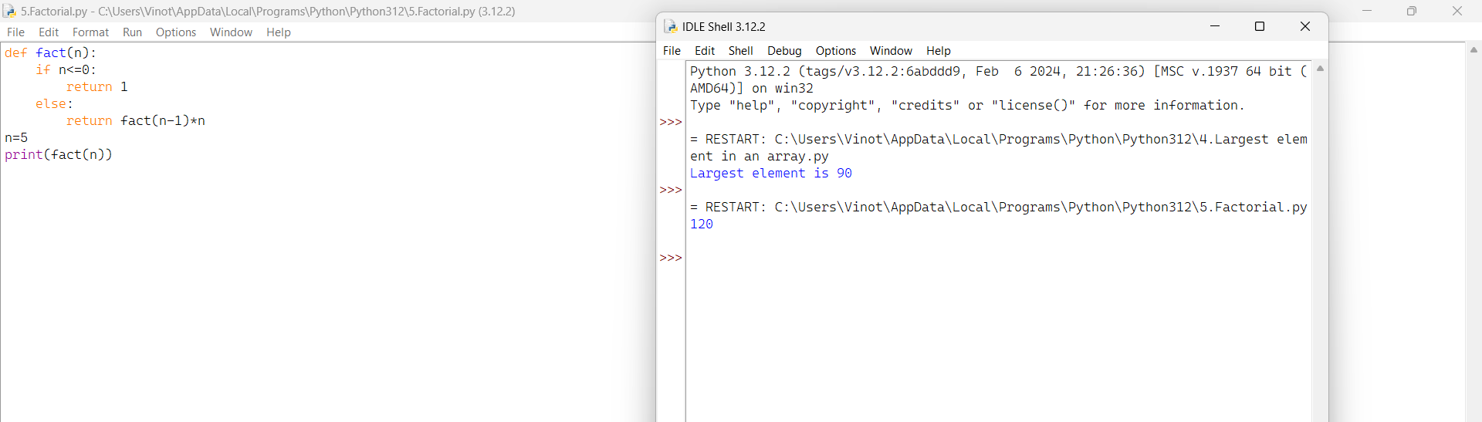

6.Copy String

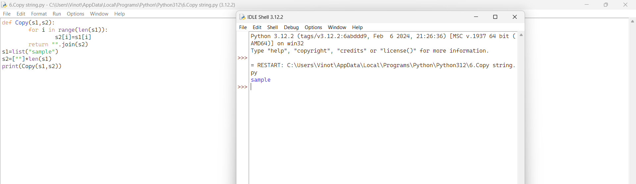

7.Reverse String

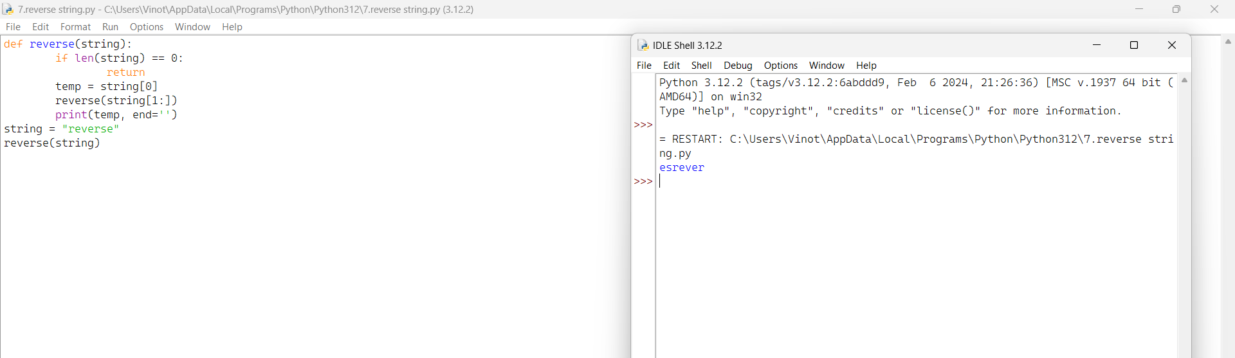

8.Generate n prime numbers

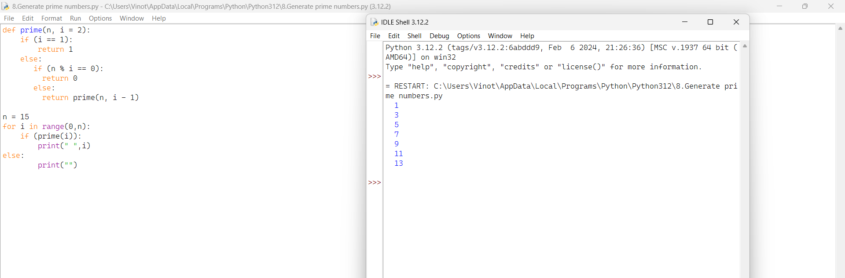

9.Check whether the given number is prime or not

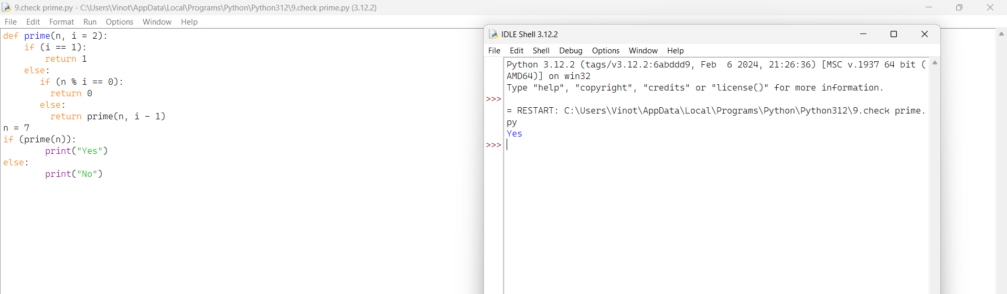

10.Check whether the given string is Palindrome or not using recursion

